LAB Instruction

What You Will Learn
- How to use CSS and style HTML documents
- How to use CSS selectors

CSS Selectors
© 2014 Randy Connolly
Modified 2023 PJ Perri
Further modified by Jim Davis

Introduction
CSS is a W3C standard for describing the appearance of HTML elements. Another common way to describe CSS’s function is to say that CSS is used to define the presentation of HTML documents. With CSS, we can assign font properties, colors, sizes, borders, background images, and even the position of elements. CSS is a language in that it has its own syntax rules. CSS can be added directly to any HTML element (via the style attribute), within the <head> element, or, most commonly, in a separate text file that contains only CSS.

Instructions
Complete the following ‘exercises’ #1- 7. After each, take a moment to reflect on the lesson the exercise was attempting to illustrate and answer the questions posed in a Word document (in a .docx) to summarize each lesson, and submit the .docx ‘report’ to the Submit folder.
Exercise 1—Inline Styles
Unzip the startingPoint folder and test exercise01.html in browser.

Add the following internal style definition and test.
<header>
<h1 style="color: red;" >Share Your Travels</h1>

Modify the following and test.
<header>
<h1 style="color: red; background-color:gray;" >Share Your Travels</h1>

Add the following embedded style to the <head> element from the previous exercise.
Exercise 2— Embedded Style Sheets
<head>
<meta charset="utf-8">
<title>Share Your Travels -- New York - Central Park</title>
<style>
h1 {
color: blue;
background-color: yellow;
}
</style>
</head>
Test it! Why didn’t it work?
Remove the inline styles created previously. Test. The <h1> element should now have blue text against a yellow background.

Add the following style rule and test.
h1, h2, h3 {
font-family: "Trebuchet MS", "Lucida Grande", "Tahoma", "sans-serif";
}
This is a grouped selector which selects all three headings.
Note that we have defined four different font faces for the headings. This is a common practice and the later fonts are used when the earlier ones are not supported by a browser. For example, the browser will use Tahoma font, when Trebuchet MS and Lucida Grande fonts are not available.

Add the following style rule after the one created in previous step and test.
h1, h2, h3 {
font-family: "Trebuchet MS", "Lucida Grande", Tahoma, sans-serif;
}
h1 {
font-family: Georgia, Cambria, "Times New Roman", serif;
}
Notice that the new style rule for h1 overrides the earlier one due to the cascade principle of location (i.e., when rules have the same specificity, then the latest are given more weight).

Change the previous style rule to the following. Before you test it, ask yourself whether this will affect the font-family of the headings.
h1, h2, h3 {
font-family: "Trebuchet MS", "Lucida Grande", Tahoma, sans-serif;
}
body {
font-family: Georgia, Cambria, "Times New Roman", serif;
}

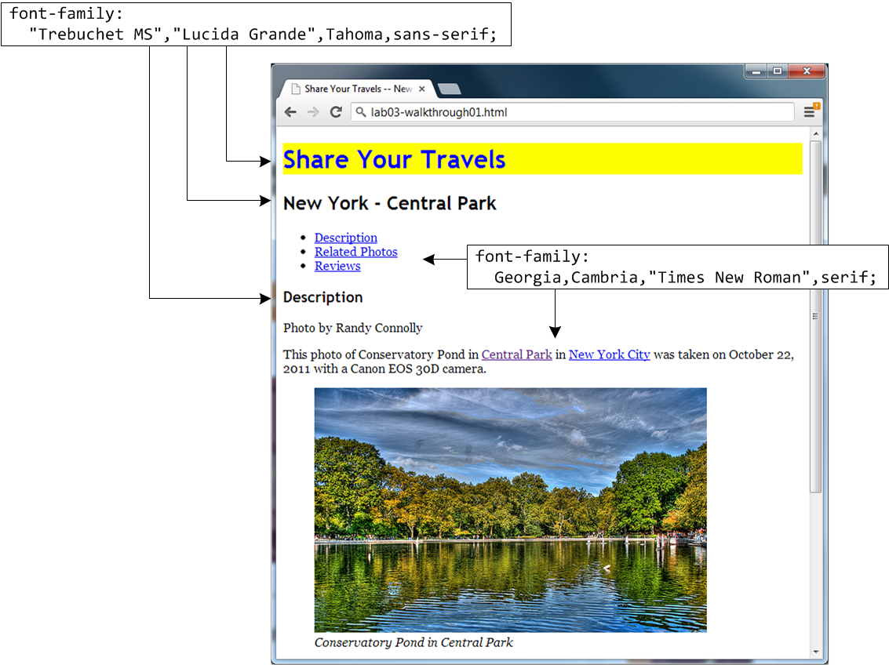

Figure 1 – Exercise 2 Complete

Exercise 3— External Style Sheet
Create a new text document with the following content and save your file as exercise03.css:
header, footer {
color: white;
background-color: #213643;
}
nav {
background-color: #728B96;
}
h1, h2, h3 {
font-family: "Trebuchet MS", "Lucida Grande", Tahoma, sans-serif;
}
body {
font-family: Georgia, Cambria, "Times New Roman", serif;
}
Notice that the first style rule uses a grouped selector, meaning that both the header and footer elements will receive the same style.

Open exercise03.html (which has the same content as the last exercise).

Add the link to this new external CSS file to the html file.

Save and test exercise03.html in browser.

Entirely unnecessary extra effort – do at your own risk.
Read up on CSS fonts from W3 Schools:
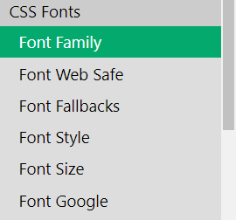
Start with Font Families and proceed to Font Google.
Make changes to the HTML and css to illustrate font styles, weights and variants.
Try out the fixed, relative and responsive text sizes.
Read theW3 Schools article Font Google, HOW TO- Google Fonts, and this article describing How to Import Google Fonts in CSS File.
Then attempt to use multiple Google Fonts, adding them to the html file
– choose three serif fonts and use serif as your fallback font.

CSS Selectors
When defining CSS rules, you will need to first need to use a selector to tell the browser which elements will be affected by the styles. CSS selectors allow you to select individual or multiple HTML elements, elements that belong together in some way, or elements that are positioned in specific ways in the document hierarchy. The previous exercises used HTML selectors. The next exercises make use of other selectors.
Exercise 4— Element, Class, and ID Selectors
Open, examine, and test exercise04.html in browser.

Add the following to the markup for this element.
<section>
<h3 id="reviews" >Reviews</h3>
<div>

Open exercise04.css, add the following style, and test.
#reviews {
border-bottom: solid 3pt #213643;
color: #ed8030;
}

Change the previous selector to the following and test.
h3#reviews
In this example the selector in the previous step and in this step are functionally equivalent. However, the one in this step is more specific, and slightly more self-documenting, so is preferable.

Switch to exercise04.html and add the following.
<section>
<h3 id="reviews" >Reviews</h3>
<div>
<p class="first" >By Ricardo on <time>September 15, 2012</time></p>
<p>Easy on the HDR buddy.</p>
</div>
<hr/>
<div>
<p class="first" >By Susan on <time>October 1, 2012</time></p>
<p>I love Central Park.</p>
</div>
<hr/>
</section>

Switch to exercise04.css and add the following style.
.first {
color: #728B96;
font-style: italic;
}

Test in browser. Remember that whenever the lab says “test in browser,” it means view the HTML file in a browser!

Attribute Selectors
An attribute selector provides a way to select HTML elements either by the presence of an element attribute or by the value of an attribute. This can be a very powerful technique, but because of uneven support by some of the browsers, not all web authors have used them.
Exercise 5— Attribute Selectors
Open exercise05.html and view in browser.

Open exercise05.css, add the following style, and test.
[title] {
cursor: help;
text-decoration: none;
padding-bottom: 3px;
border-bottom: 2px dotted blue;
}
This will select every element that contains a title attribute. Examine the HTML to see which elements contain a title attribute.

Modify the attribute to the following and test.
[title="Calgary"] {
This selects only the one element whose title attribute is exactly Calgary.

Modify the attribute (add the asterisk) to the following and test.
[title*="Calgary"] {
This selects all elements that contain the text Calgary within in.

Modify the attribute (add the caret) to the following and test.
[title^="Calgary"] {
This selects all elements that begin with the text Calgary.

Pseudo-Class Selectors
The next exercise illustrates the use of pseudo-class selectors, which do not apply to an HTML element, but targets either a particular state or, in CSS3, a variety of family relationships. The most common use of this type of selectors is for targeting link states. By default, the browser displays link text blue and visited text links purple. Exercise 3.6 illustrates the use of pseudo-class selectors to style not only the visited and unvisited link colors, but also the hover color, which is the color of the link when the mouse is over the link. Do be aware that this state does not occur on touch screen devices.

Exercise 6—Pseudo Selectors and Lists
Open exercise06.html.

Switch to exercise06.css and add the following style to exercise06.css and test.
a:hover {
background-color: #FFFF99;
}
To test this style, you must hover your mouse over a link.

Add the following style to exercise06.css and test.
nav ul li {
list-style: none;
}
This removes the bullet from the navigation <li> elements

Add the following and test.
nav ul li {
list-style: none;
display: inline;
}
By changing the <li> elements from their default display: block value, the list items are no longer block elements (thus existing on their own lines) but are now inline elements.

Add the following and test.
nav ul li {
list-style: none;
display: inline;
margin: 1em;
}
That adds space to the left and right of each list item. Why doesn’t it also add space to the top and bottom as well? The answer is that top and bottom margins are ignored for inline elements.

Add the following and test.
nav {
padding: 0.25em;
}
This adds padding space within the <nav> element.

Add the following and test.
nav a {
padding: 0.25em;
}
This makes the size of the <a> element the same as the container, which makes the hover size the same as the container. The result should look similar to that shown in figure below.

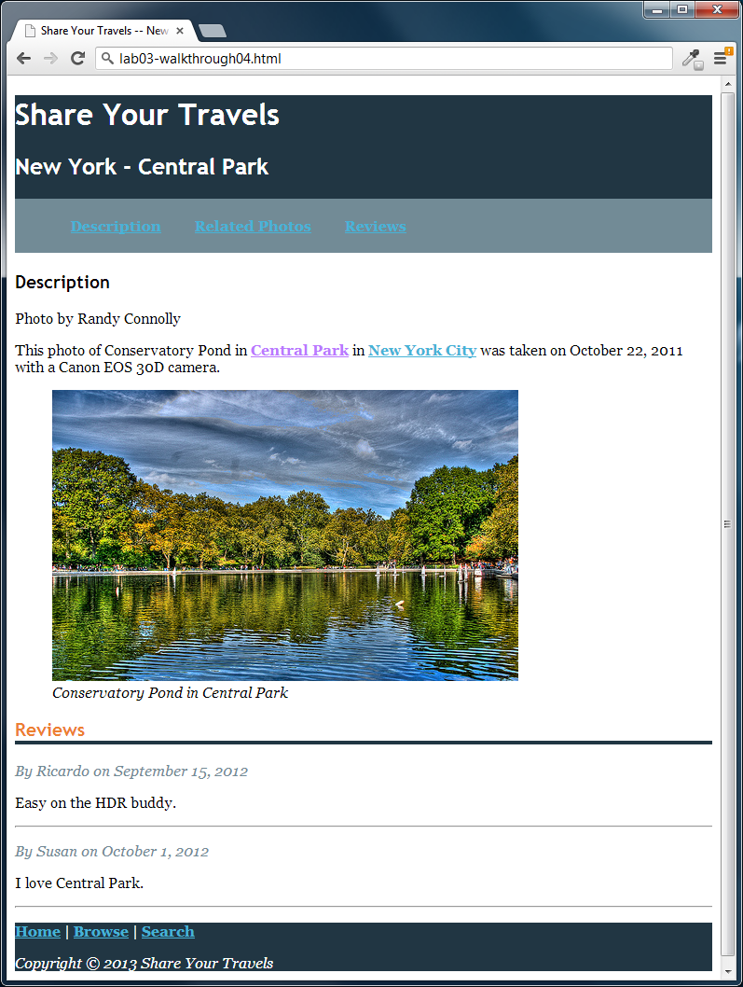
Figure 2 – Exercise 6 Complete

Contextual Selectors
A contextual selector allows you to select elements based on their ancestors, descendants, or siblings. That is, it selects elements based on their context or their relation to other elements in the document tree. While some of these contextual selectors are used relatively infrequently, almost all web authors find themselves using descendant selectors.

Exercise 7— Contextual Selector
Open exercise07.html (which has the same content as the last exercise).

Switch to exercise07.css and add the following style and test.
p {
color: #983C2A;
}
This changes the text color of every occurrence of the <p> element.

Modify the style as follows. Before you test, see if you can figure out which text will be affected by the change to this descendent selector.
section p {
color: #983C2A;
}
This selects all <p> elements that exist somewhere within a <section> element. That selects all of them except for the ones within the <footer> element.

Modify the style as follows and test.
div p {
color: #983C2A;
}
This selects all <p> elements that exist somewhere within a <div> element.

Modify the style as follows and test. As with the previous steps, see if you can figure out which text will be affected by the change before you test it.
section>p {
color: #983C2A;
}
This doesn’t select the review <p> elements because they are contained within <div> elements, and thus are not direct children of a <section> element.

Modify the style as follows and test.
h3+p {
color: #983C2A;
}
This selects any <p> elements that immediately follow an <h3> element.

Modify the style as follows and test.
h3~p {
color: #983C2A;
}
This selects any <p> elements that share the same parent as an <h3> element.

Summary
Really take a moment to reflect on all that you’ve explored in these 7 exercises. Look back the steps and, in your own words, try to capture the concepts (listed below) that they were illustrating.
- Inline vs embedded vs external CSS
- Group selectors
- Specificity
- Selectors: ID, element, attribute
- Pseudo-class selectors
- Contextual selectors
Is something unclear? Read the textbook or find authoritative online sources (probably not stackoverflow) and work out what is going on.
Write down all this down (informal citations in footnotes would be used if ideas came from either online sources or personal conversation.

Quite useful and important to know, maybe even more than pseudo class selectors according to Jordan Pratt (Personal conversation Jan 31, 2023

